Chapter 7, Solution 55.

For t < 0, consider the circuit shown in Fig. (a).
24 V

+
−
3 
2 
i
0.5 H
i_{o}
i_{o}
+
−
4i_{o}
(a)
+
v
−
20 V

+
−
8 
2 
0.5 H
(b)
+
v
−

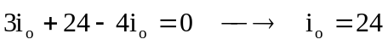
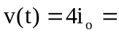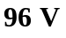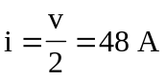

For t > 0, consider the circuit in Fig. (b).
 